[Unit Testing Report]
[Code can run and unit test in python3.8]
https://github.com/CHAOYUEYANG2012/tdd-hangman
CHAOYUE YANG 338543
TDD:

To implement a TDD hangman game we firstly get unit test cases done while implement functions:
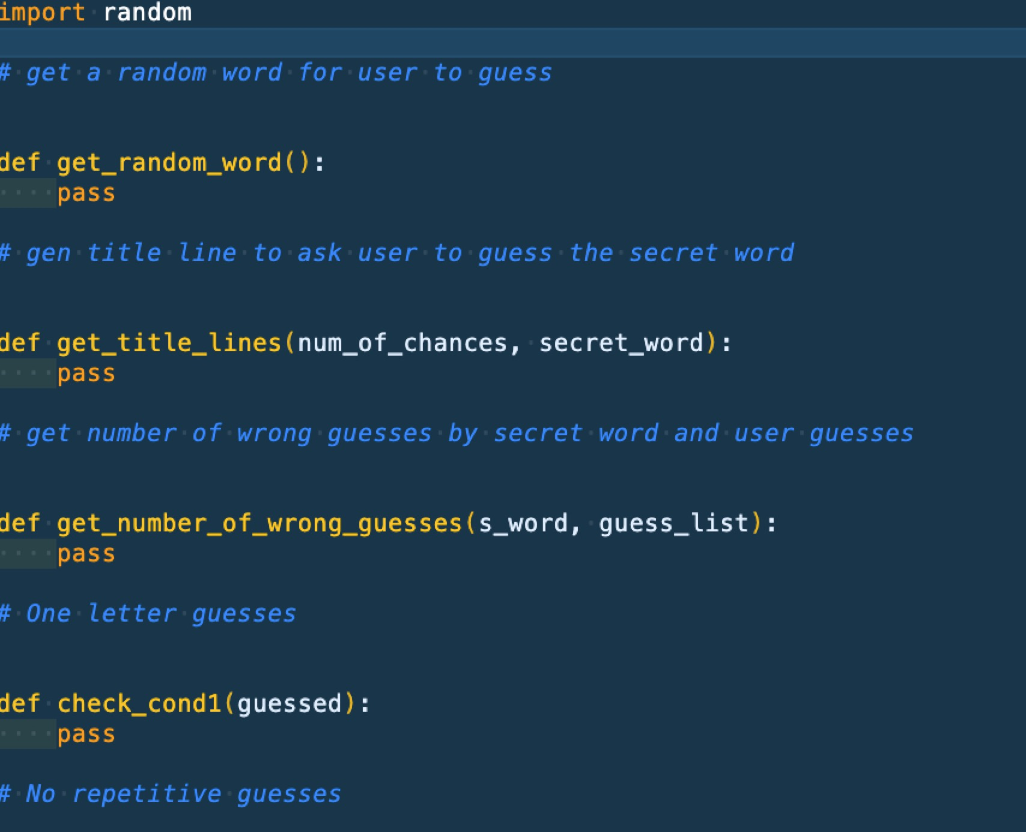
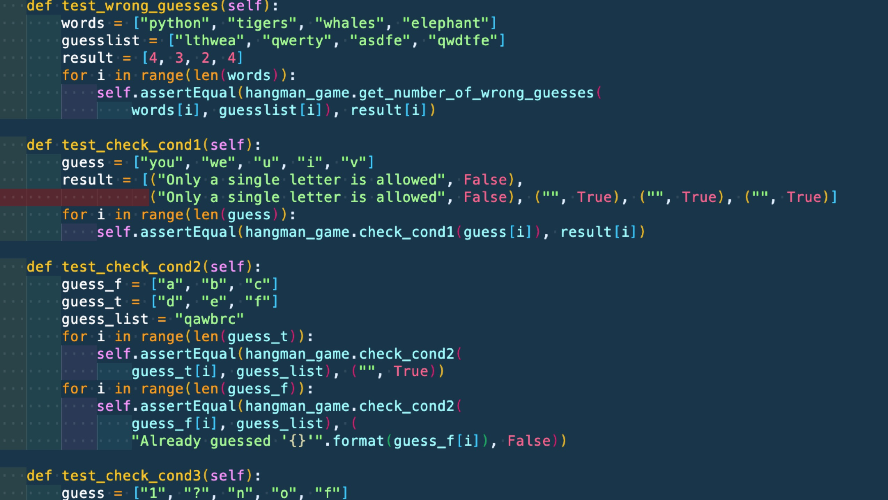

All the unit test will be failed at the time:
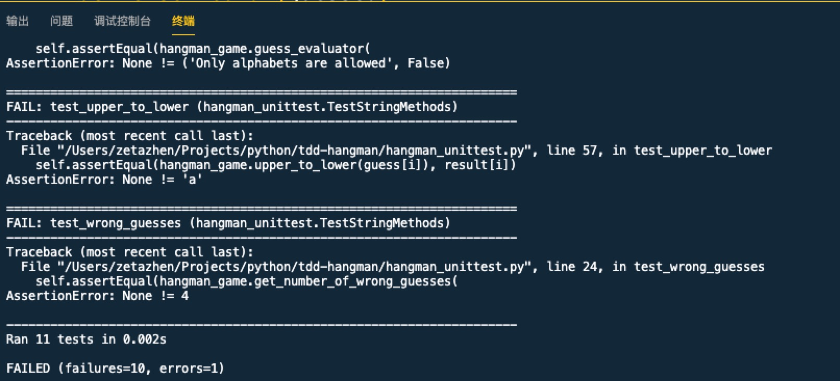

but after I implemented all functions with all unit tests passed, I was more confident that all the functions should be correct:

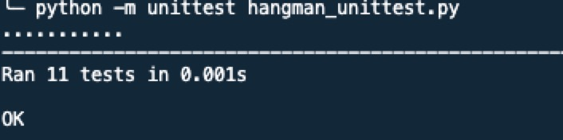

Refactor:

Then I started to review my code and found some bad smells of my code:

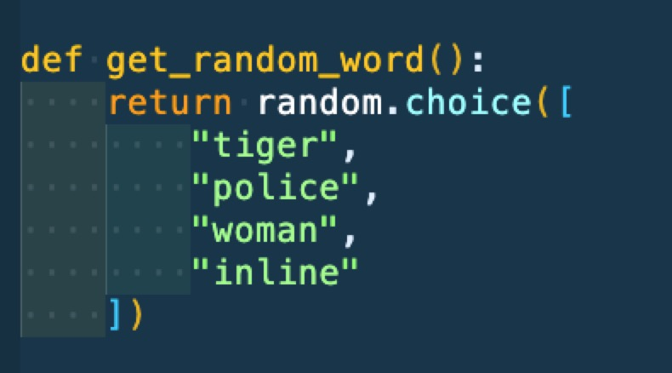
1.

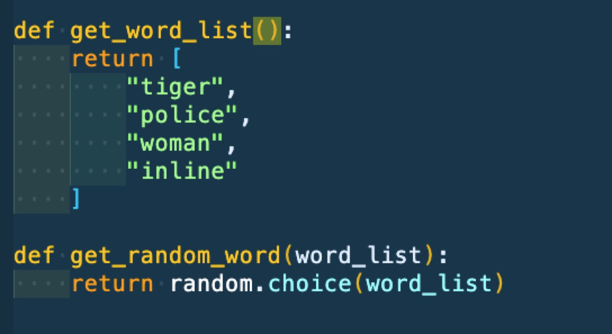
The secret word list was hard coded, so I think I should change it in the way that I can load it from somewhere else like a txt file or even from internet if needed.

somewhere else like a txt file or even from internet if needed.

then I added a function get word list and pass the result into get random_word, so I can change the logic of get word list into get from a file if needed.

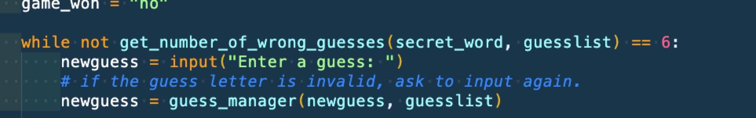
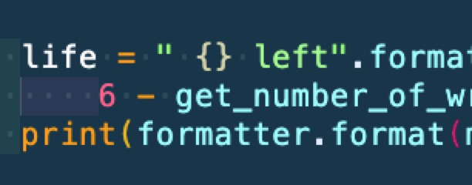
2.

the magic number 6 are everywhere, so I think I can put them into a config instead:

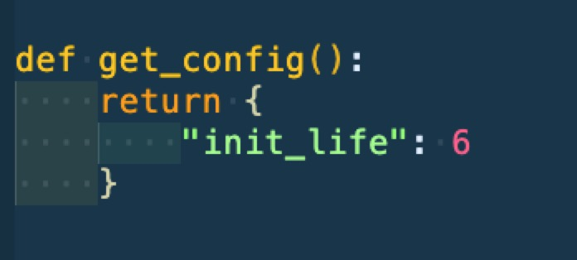

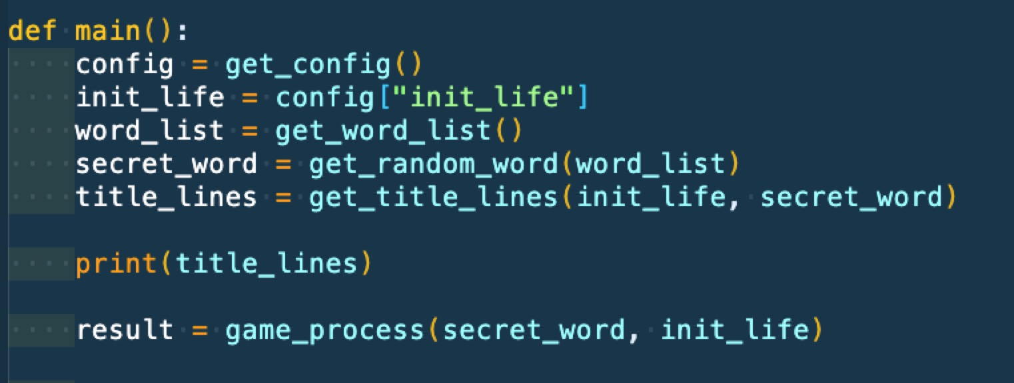
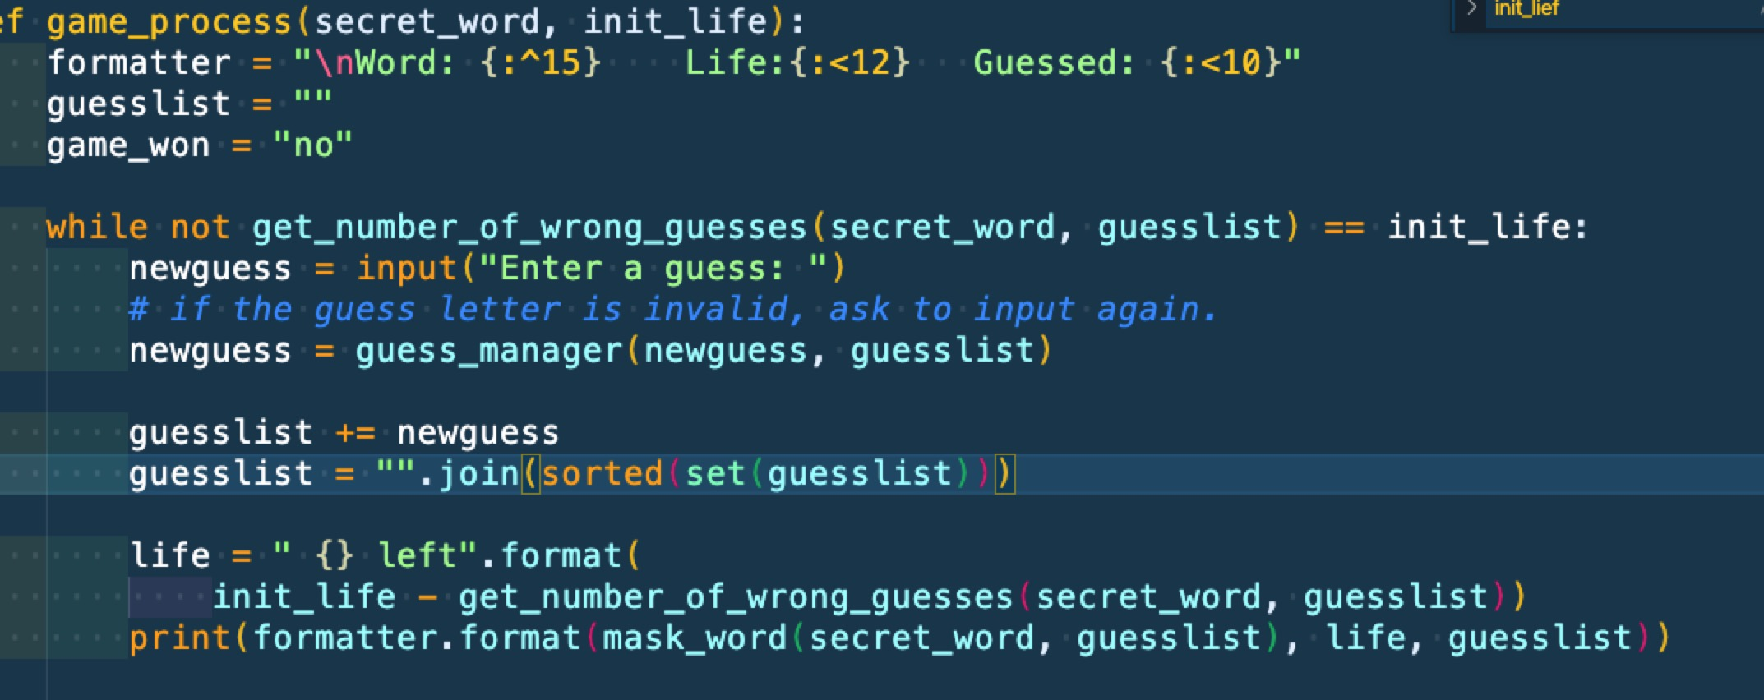

then the magic number 6 is long gone. I can change the number easily by modify the config

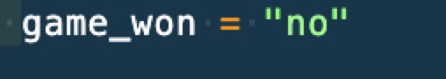
3.

this flag should be bool instead:

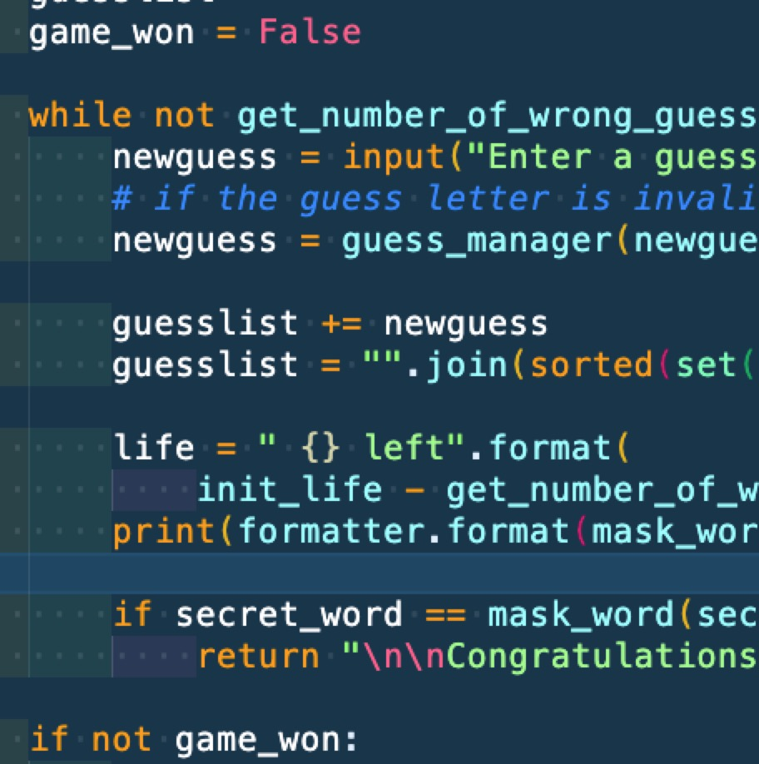

It is much better now.
when I run unit tests after all the refactors, they're passed. Then I can consider the refactor was done with no side effects.
